1. Write a C# Sharp program to accept a coordinate point in an XY coordinate system and determine

in which quadrant the coordinate point lies.

class Soln

{

public void coordinates(int x, int y)

{

if (x > 0 && y > 0)

{

Console.WriteLine("The coordinate point (" + x + " , " + y + ") lies in the First quadrant.");

}

else if (x < 0 && y > 0)

{

Console.WriteLine("The coordinate point (" + x + " , " + y + ") lies in the Second quadrant.");

}

else if ( x < 0 && y < 0)

{

Console.WriteLine("The coordinate point (" + x + " , " + y + ") lies in the Third quadrant.");

}

else if ( x > 0 && y < 0)

{

Console.WriteLine("The coordinate point (" + x + " , " + y + ") lies in the Fourth quadrant.");

}

else

{

Console.WriteLine("The coordinate point (" + x + " , " + y + ") lies in the Origin.");

}

}

}

// Driver Code

class Program

{

public static void Main(string[] args)

{

int x, y;

Console.WriteLine("Enter X Value");

x = Convert.ToInt32(Console.ReadLine());

Console.WriteLine("Enter Y Value");

y = Convert.ToInt32(Console.ReadLine());

Soln soln = new Soln();

soln.coordinates(x,y);

}

}

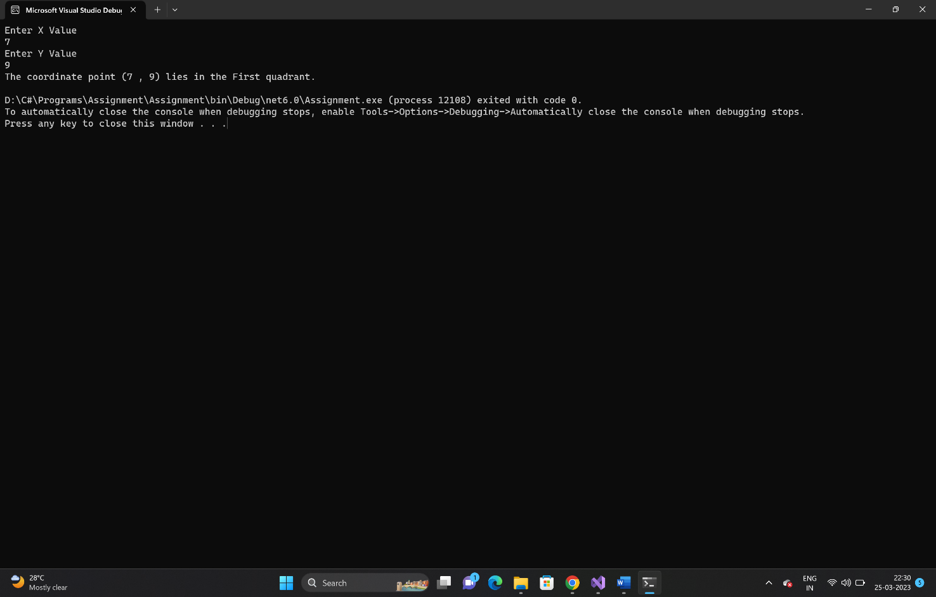

2. Write a C# Sharp program to read roll no, name and marks of three subjects and calculate the

total, percentage and division.

class Soln

{

public void Student(int p_mark, int ch_mark, int cs_mark, double total_marks, double percentage, string division)

{

total_marks = p_mark + ch_mark + cs_mark;

Console.WriteLine("Total Marks = " + total_marks);

percentage = total_marks / 3;

string percent = percentage.ToString("0.00");

Console.WriteLine("Percentage = " + percent);

if (percentage >= 80)

{

division= "First";

Console.WriteLine("Division = " + division);

}

else if ( percentage >=60 && percentage < 80)

{

division = "Second";

Console.WriteLine("Division = " + division);

}

else

{

division = "Third";

Console.WriteLine("Division = " + division);

}

}

}

// Driver Code

class Program

{

public static void Main(string[] args)

{

Soln soln= new Soln();

Console.WriteLine("Enter Roll No");

int rollno = Convert.ToInt32(Console.ReadLine());

Console.WriteLine("Enter Name of the Student");

string stud_name = Console.ReadLine();

Console.WriteLine("Enter Physics Mark");

int p_mark = Convert.ToInt32(Console.ReadLine());

Console.WriteLine("Enter Chemistry Mark");

int ch_mark = Convert.ToInt32(Console.ReadLine());

Console.WriteLine("Enter Computer Application Mark");

int cs_mark = Convert.ToInt32(Console.ReadLine());

double total_marks = 0;

double percentage = 0;

string division = null;

Console.WriteLine("Roll No : " + rollno);

Console.WriteLine("Name of Student : " + stud_name);

Console.WriteLine("Marks in Physics : " + p_mark);

Console.WriteLine("Marks in Chemistry : " + ch_mark);

Console.WriteLine("Marks in Computer Application : " + cs_mark);

soln.Student(p_mark, ch_mark, cs_mark, total_marks, percentage, division);

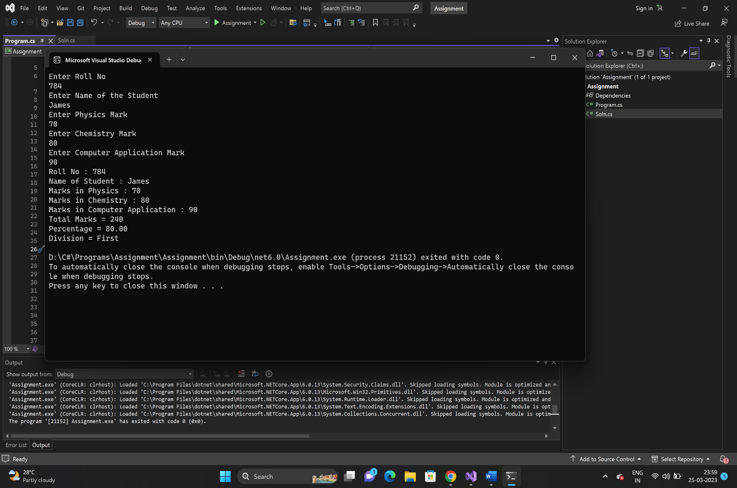

3. Write a program in C# Sharp to calculate and print the Electricity bill of a given customer. The

customer id., name and unit consumed by the user should be taken from the keyboard and display

the total amount to pay to the customer.

class Soln

{

public void EB(int c_unit, int mincharge, double charge, double total_amt)

{

if (c_unit <= 199)

{

charge = 1.20;

total_amt = c_unit * charge;

if (total_amt > 400)

{

total_amt = (total_amt) + 15 / 100;

Console.WriteLine("Total Bill : " + total_amt);

}

else if (total_amt < 100)

{

Console.WriteLine("Total Bill : " + mincharge);

}

else

{

Console.WriteLine("Total Bill : " + total_amt);

}

}

else if (c_unit >= 200 && c_unit < 400)

{

charge = 1.50;

total_amt = c_unit * charge;

if (total_amt > 400)

{

total_amt = (total_amt) + 15 / 100;

Console.WriteLine("Total Bill : " + total_amt);

}

else if (total_amt < 100)

{

Console.WriteLine("Total Bill : " + mincharge);

}

else

{

Console.WriteLine("Total Bill : " + total_amt);

}

}

else if (c_unit >= 400 && c_unit < 600)

{

charge = 1.80;

total_amt = c_unit * charge;

if (total_amt > 400)

{

total_amt = (total_amt) + 15 / 100;

Console.WriteLine("Total Bill : " + total_amt);

}

else if (total_amt <100)

{

Console.WriteLine("Total Bill : " + mincharge);

}

else

{

Console.WriteLine("Total Bill : " + total_amt);

}

}

else if (c_unit >= 600)

{

charge = 2.00;

total_amt = c_unit * charge;

if (total_amt > 400)

{

total_amt = (total_amt) + 15 / 100;

Console.WriteLine("Total Bill : " + total_amt);

}

else if (total_amt < 100)

{

Console.WriteLine("Total Bill : " + mincharge);

}

else

{

Console.WriteLine("Total Bill : " + total_amt);

}

}

}

}

// Driver Code

class Program

{

public static void Main(string[] args)

{

Soln soln= new Soln();

Console.WriteLine(" Enter Customer ID");

int cust_id = Convert.ToInt32(Console.ReadLine());

Console.WriteLine("Enter Customer name");

string cust_name =Console.ReadLine();

Console.WriteLine("Enter Unit Consumed");

int c_unit = Convert.ToInt32(Console.ReadLine());

int mincharge = 100;

double charge =0;

double total_amt = 0;

soln.EB(c_unit, mincharge, charge, total_amt);

}

}

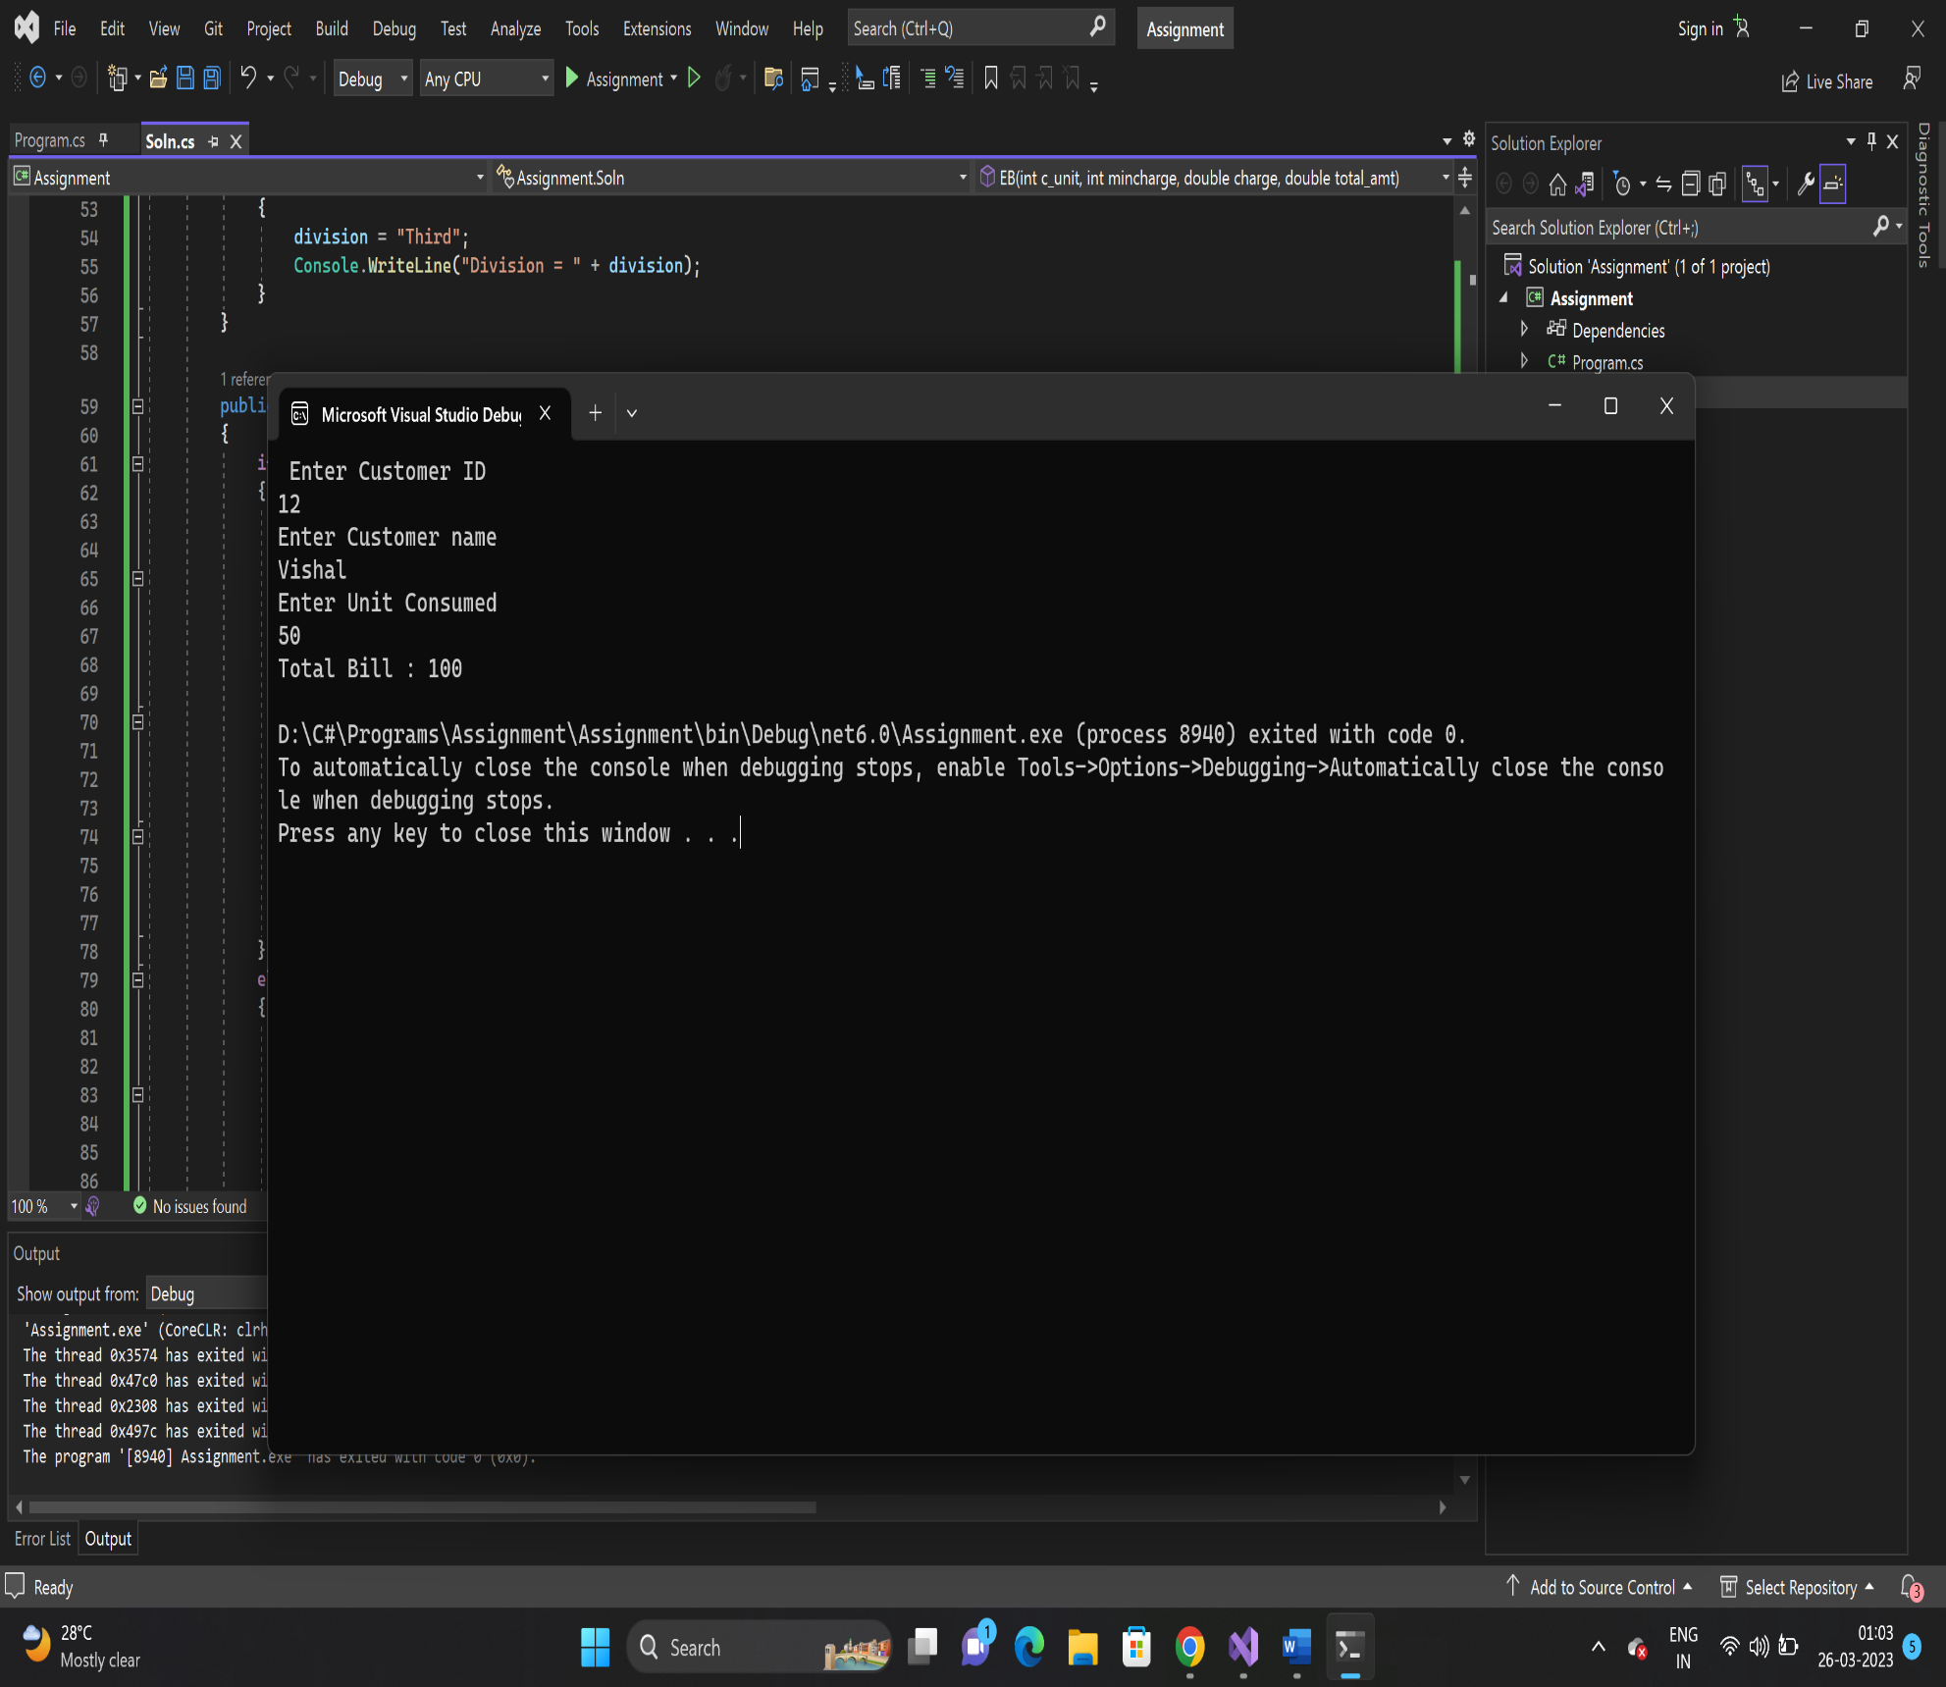

4.a) Write a program in C# Sharp to make such a pattern like right angle triangle with number

increased by 1.

class Soln

{

public void Pattern1(int total_no, int i, int j, int number)

{

for (i=1; i<=total_no; i++)

{

for ( j=1; j<=i; j++)

{

Console.Write(number);

++number;

}

Console.WriteLine("\n");

}

}

}

//Driver Code

class Program

{

public static void Main(string[] args)

{

Soln soln= new Soln();

Console.WriteLine("Enter the Total numbers of rows in a Triangle");

int total_no = Convert.ToInt32(Console.ReadLine());

int i =0;

int j=0;

int number = 1;

soln.Pattern1(total_no, i, j, number);

}

}

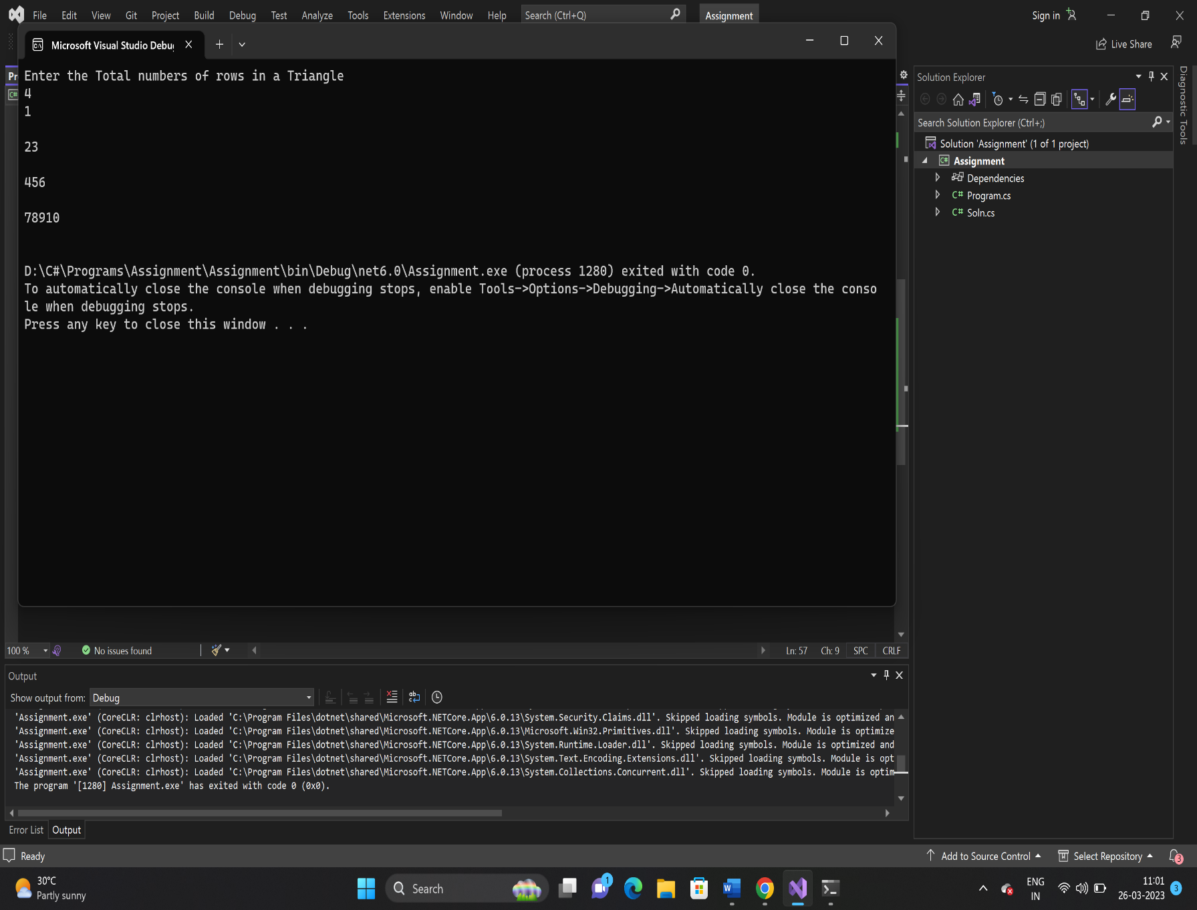

4.b)

class Soln

{

public void pattern2(int i , int j, int k, int rows, int spc, int t)

{

spc = rows + 3;

for (i = 1; i <= rows; i++)

{

for (k = spc; k >= 1; k--)

{

Console.Write(" ");

}

for (j = 1; j <= i; j++)

Console.Write("{0} ", t++);

Console.Write("\n");

spc--;

}

}

}

//Driver Code

class Program

{

public static void Main(string[] args)

{

Soln soln = new Soln();

int i =0, j = 0, k = 0,spc = 0 ;

int rows = 1,t = 1;

Console.WriteLine("Enter the total number of rows in a triangle");

rows= Convert.ToInt32(Console.ReadLine());

soln.pattern2(i, j, k, rows,spc,t);

}

}

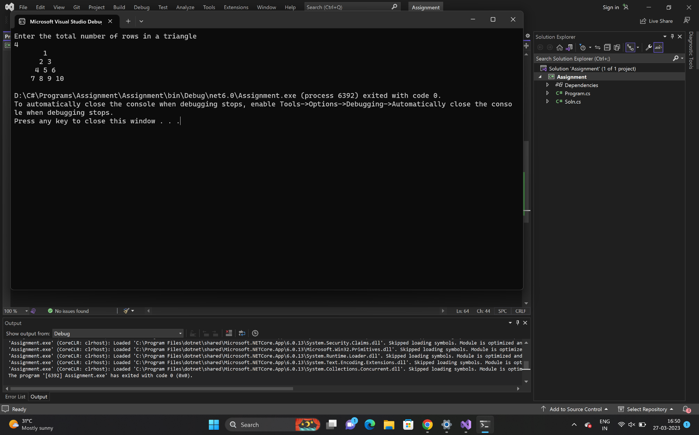

5. Write a program in C# Sharp to

a. read n number of values in an array and display it in reverse order.

b. copy the elements one array into another array

c. find the sum of all elements of the array

d. count a total number of duplicate elements in an array.

e. print all unique elements in an array

f. find the second largest element in an array

class Soln

{

public void Array(int i, int n)

{

//Reverse an array

int[] arr1 = new int[10];

Console.Write("Input number of elements in the array :\n", n);

for (i = 0; i < n; i++)

{

Console.Write("element - {0} : ", i);

arr1[i] = Convert.ToInt32(Console.ReadLine());

}

Console.Write("\n\nThe values store into the array in reverse are :\n");

for (i = n - 1; i >= 0; i--)

{

Console.Write("{0} ", arr1[i]);

Console.Write("\n");

}

//Dupicate Array

int[] arr2 = new int[10];

for (i = 0; i < n; i++)

{

arr2[i] = arr1[i];

}

Console.WriteLine("The copied values of arr1 into arr2");

for (i = 0; i < n; i++)

{

Console.WriteLine("{0} ", arr2[i]);

}

//sum of elements in an array

int sum = 0;

for (i = 0; i < n; i++)

{

sum += arr1[i];

}

Console.WriteLine("Sum of all elements stored in the array is : {0}", sum);

//count total no of duplicate elements in an array

int[] arr3 = new int[10];

int mm = 1, ctr = 0, j;

for (i = 0; i < n; i++)

{

for (j = 0; j < n; j++)

{

if (arr1[i] == arr2[j])

{

arr3[j] = mm;

mm++;

}

}

mm = 1;

}

for (i = 0; i < n; i++)

{

if (arr3[i] == 2) { ctr++; }

}

Console.Write("The number of duplicate elements is: {0} \n", ctr);

//unique numbers in an array

int k;

Console.Write("\nThe unique elements found in the array are : ");

for (i = 0; i < n; i++)

{

ctr = 0;

for (j = 0; j < i - 1; j++)

{

if (arr2[i] == arr2[j])

{

ctr++;

}

}

for (k = i + 1; k < n; k++)

{

if (arr2[i] == arr2[k])

{

ctr++;

}

if (arr2[i] == arr2[i + 1])

{

i++;

}

}

if (ctr == 0)

{

Console.Write("{0} \n", arr2[i]);

}

}

//second largest number in an array

int lrg1, lrg2;

lrg1 = 0;

j = 0;

for (i = 0; i < n; i++)

{

if (lrg1 < arr2[i])

{

lrg1 = arr2[i];

j = i;

}

}

lrg2 = 0;

for (i = 0; i < n; i++)

{

if (i == j)

{

i++; /* ignoring the largest element */

i--;

}

else

{

if (lrg2 < arr2[i])

{

lrg2 = arr2[i];

}

}

}

Console.Write("The Second largest element in the array is : {0} ", lrg2);

}

}

//Driver Code

class Program

{

public static void Main(string[] args)

{

Soln soln= new Soln();

int i = 0, n=0;

Console.Write("Input the number of elements to store in the array :");

n = Convert.ToInt32(Console.ReadLine());

soln.Array(i, n);

}

}

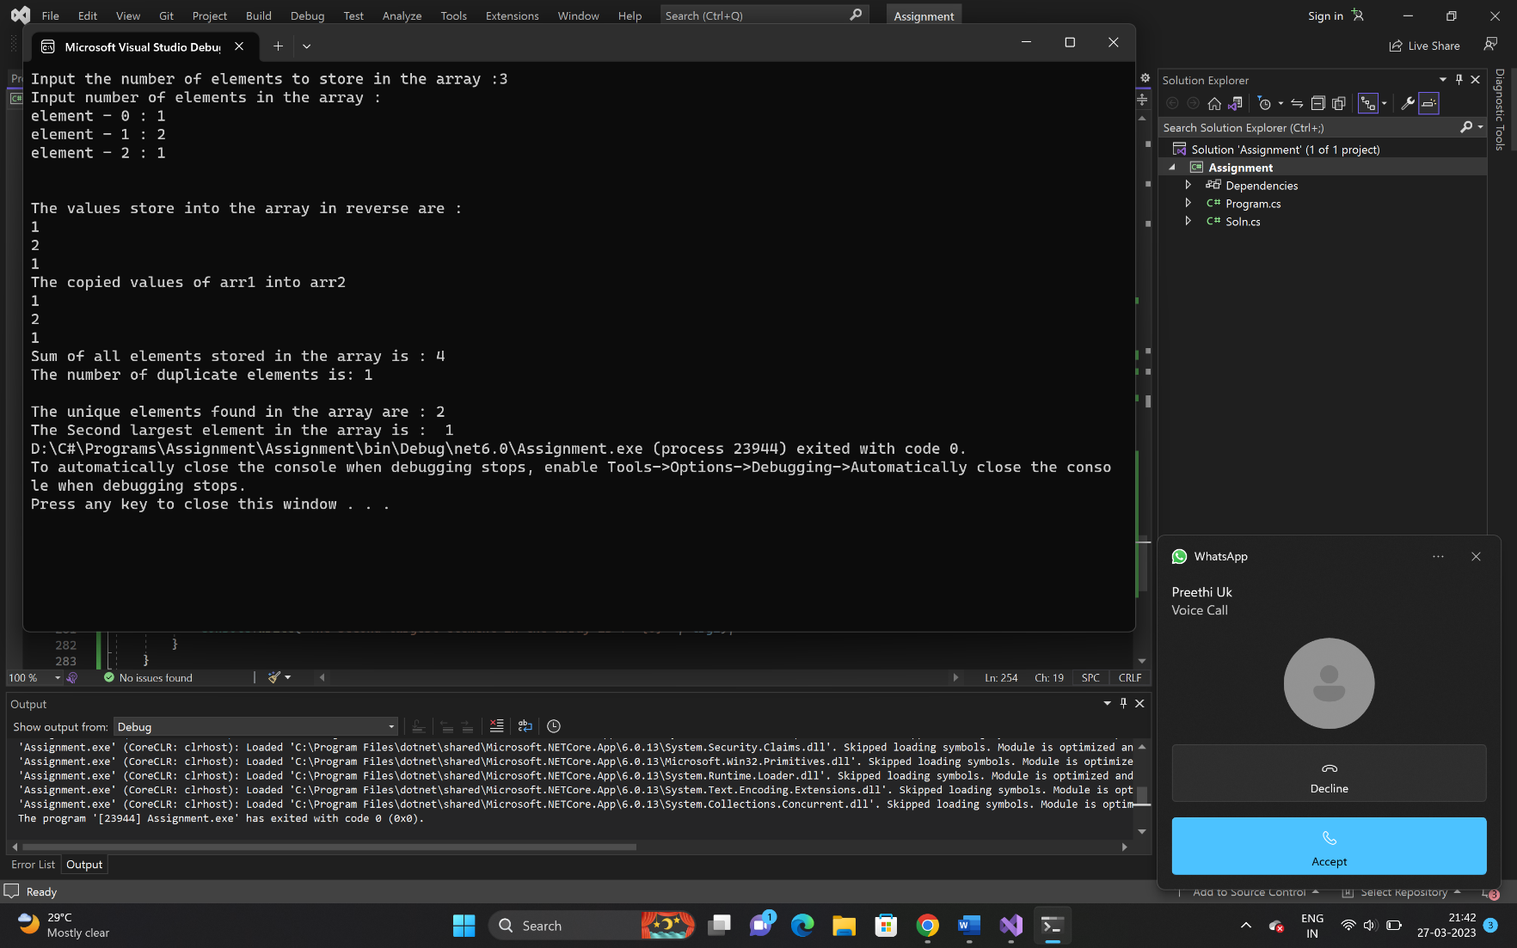

6. Write a program in C# Sharp to find transpose of a given matrix.

class Soln

{

public void matrix(int r, int c)

{

int[,] arr1 = new int[30, 30];

Console.WriteLine("Enter a array elements:");

for (int i = 0; i < r; i++)

{

for (int j = 0; j < c; j++)

{

arr1[i, j] = Convert.ToInt32(Console.ReadLine());

}

}

Console.WriteLine("transpose Matrix is:");

for (int i = 0; i < r; i++)

{

for (int j = 0; j < c; j++)

{

Console.Write(arr1[j, i] + " ");

}

Console.WriteLine(" ");

}

}

}

//Driver Code

class Program

{

public static void Main(string[] args)

{

Soln soln= new Soln();

int i, j, r, c;

int[,] arr1 = new int[50, 50];

int[,] brr1 = new int[50, 50];

Console.Write("Rows : ");

r = Convert.ToInt32(Console.ReadLine());

Console.Write("Columns : ");

c = Convert.ToInt32(Console.ReadLine());

soln.matrix(r, c);

}

}

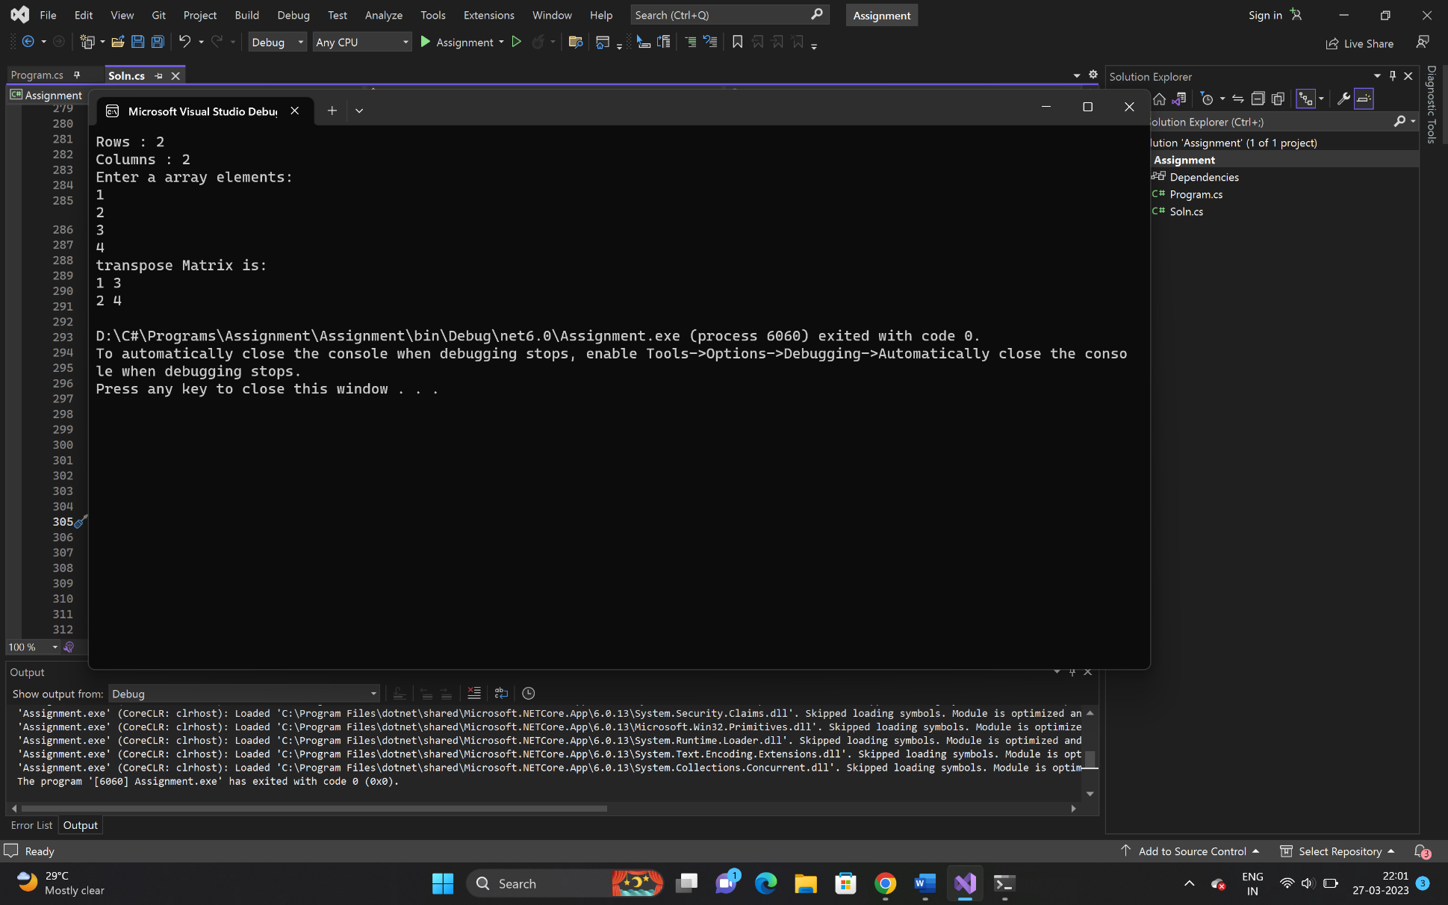

8. Write a program in C# Sharp to count the total number of words in a string.

class Soln

{

public void Alph(string str, int i, int wrd, int l)

{

l = 0;

wrd = 1;

while (l <= str.Length - 1)

{

if (str[l] == ' ' || str[l] == '\n' || str[l] == '\t')

{

wrd++;

}

l++;

}

Console.Write("Total number of words in the string is : {0}\n", wrd);

}

}

//Driver Code

class Program

{

public static void Main(string[] args)

{

Soln soln= new Soln();

string str;

int i=0, wrd=0, l = 0;

Console.Write("Input the string : ");

str = Console.ReadLine();

soln.Alph(str, i, wrd, l);

}

}

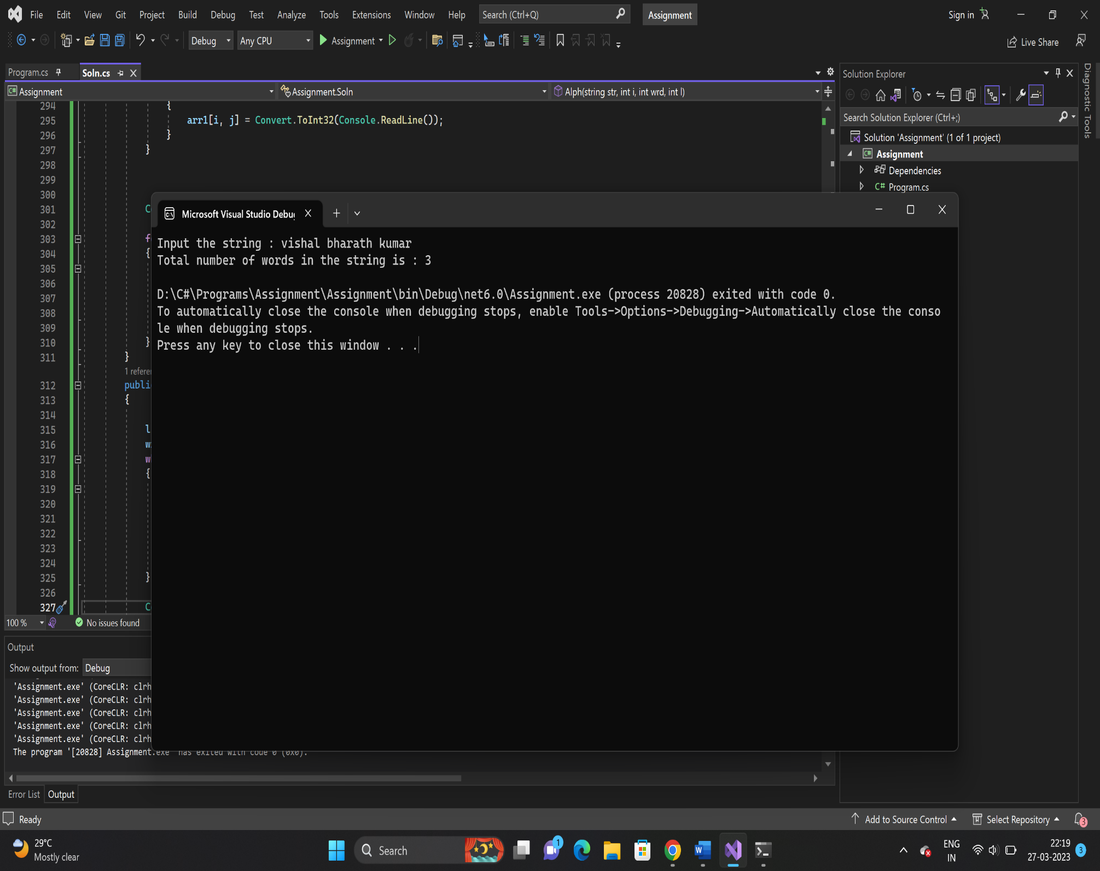

9. Write a program in C# Sharp to count a total number of alphabets, digits and special characters in

a string.

class Soln

{

public void StringCount(string psw)

{

int alphaCount = 0;

int numCount = 0;

int splCount = 0;

for (int i = 0; i < psw.Length; i++)

{

if ((psw[i] >= 'a' && psw[i] <= 'z') || (psw[i] >= 'A' && psw[i] <= 'Z'))

{

alphaCount++;

}

else if (psw[i] >= '0' && psw[i] <= '9')

{

numCount++;

}

else

{

splCount++;

}

}

Console.WriteLine("Alphabets count in a string is: " + alphaCount);

Console.WriteLine("Numbers count in a string is: " + numCount);

Console.WriteLine("Special characters count in a string is: " + splCount);

}

}

//Driver Code

class Program

{

public static void Main(string[] args)

{

Soln soln= new Soln();

string psw;

Console.WriteLine("Enter a String : ");

psw= Console.ReadLine();

soln.StringCount(psw);

}

}

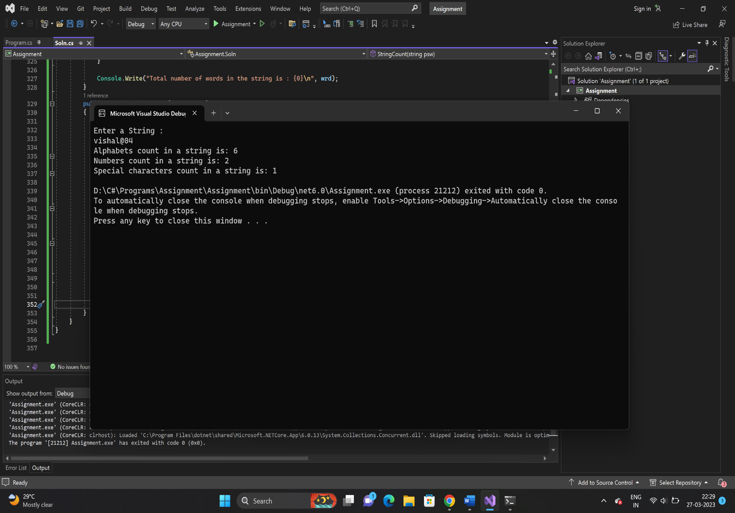

10. Write a C# Sharp program to find the middle character(s) of a given string. Return the middle

character if the length of the string is odd and return two middle characters if the length of the

string is even.

class Soln

{

public void Stringtxt(string txt)

{

string x;

int l = 1 - txt.Length % 2;

x=txt.Substring(txt.Length / 2 - l, 1 + l);

Console.WriteLine(x);

}

}

//Driver Code

class Program

{

public static void Main(string[] args)

{

Soln soln = new Soln();

string txt;

Console.Write("Input the string : ");

txt= Console.ReadLine();

soln.Stringtxt(txt);

}

}

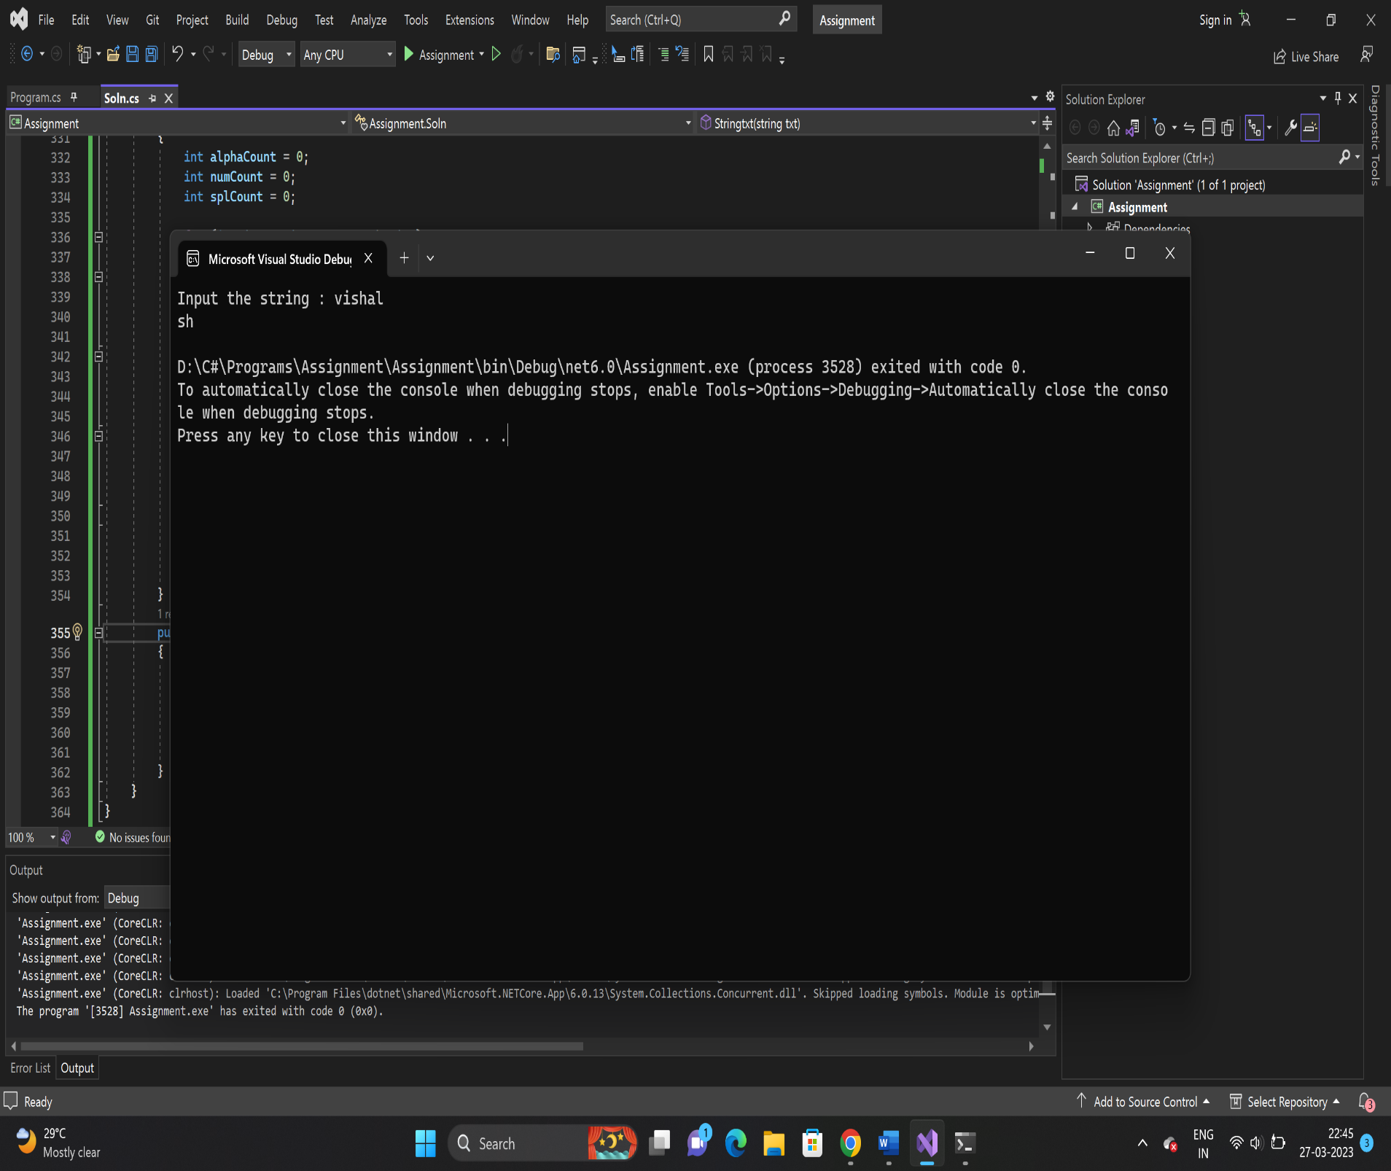

11. Write a program in C# Sharp to create a function to display the n number Fibonacci sequence.

class Soln

{

public void fibb(int num1,int num2, int n)

{

for (int i = 3; i <=n; ++i)

{

Console.Write(num2);

int temp = num1;

num1 = num2;

num2 = temp + num1;

}

}

}

// Driver Code

class Program

{

public static void Main(string[] args)

{

Soln soln= new Soln();

Console.Write("Input number of Fibonacci Series : ");

int n = Convert.ToInt32(Console.ReadLine());

int num1 = 0;

int num2 = 1;

Console.Write(num1);

Console.Write(num2);

soln.fibb(n,num1, num2);

}

}

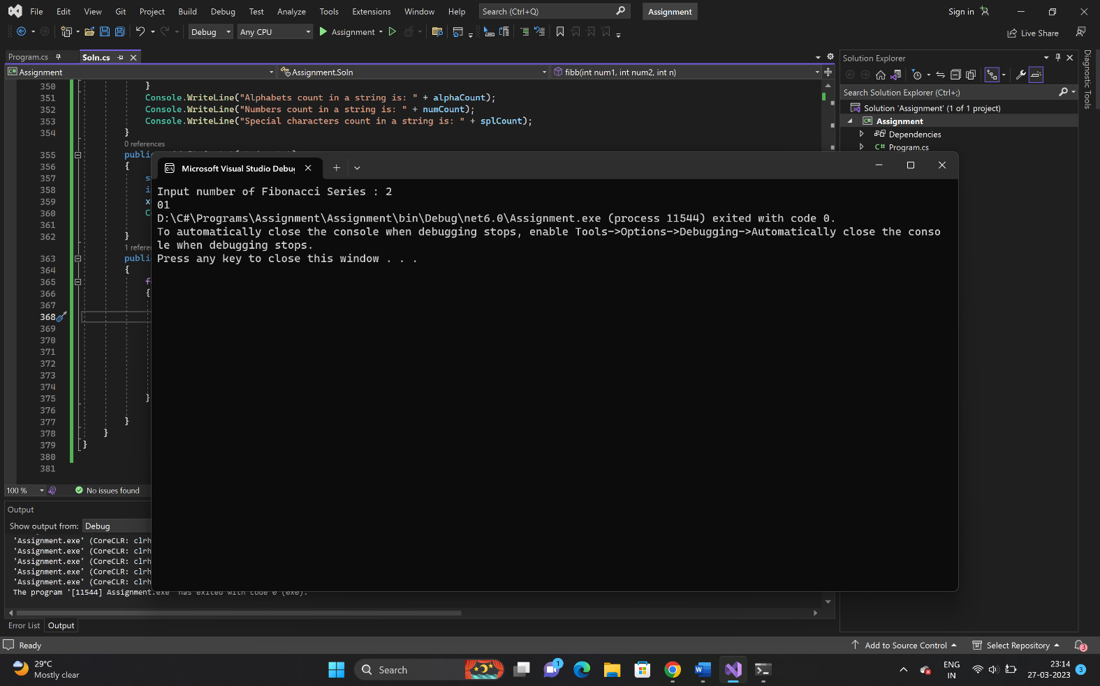

12. Write a program in C# Sharp to create a function to check if a given number is Armstrong number

or not

class Soln

{

public void arms(int temp, int num, int r, int sum)

{

for (temp = num; num != 0; num = num / 10)

{

r = num % 10;

sum = sum + (r * r * r);

}

if (sum == temp)

Console.Write("{0} is an Armstrong number.\n", temp);

else

Console.Write("{0} is not an Armstrong number.\n", temp);

}

}

//Driver Code

class Program

{

public static void Main(string[] args)

{

Soln soln= new Soln();

int num, r=0, sum = 0, temp=0;

Console.Write("Input a number: ");

num = Convert.ToInt32(Console.ReadLine());

soln.arms(temp, num, r, sum);

}

}

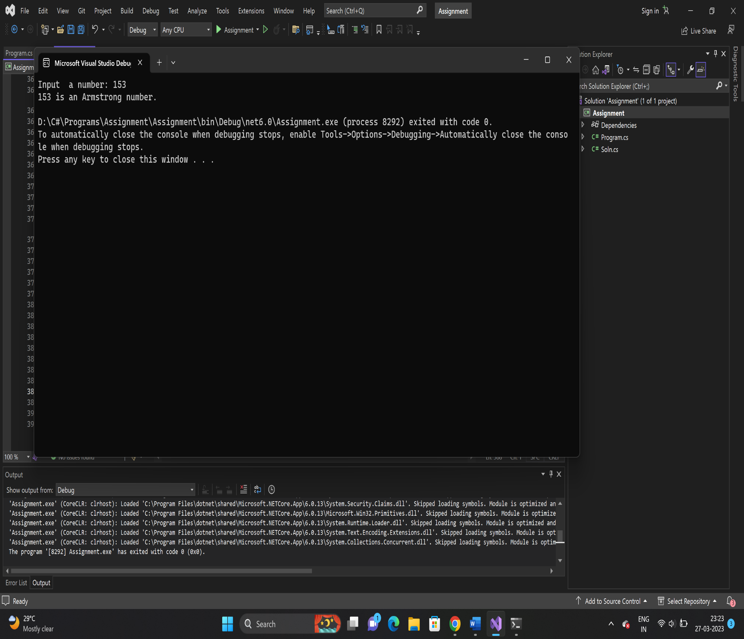

13. Write a program in C# Sharp to create a function to check if a given number is Perfect number or

Not

class Soln

{

public void perfect(int i, int n, int sum)

{

for (i = 1; i < n; i++)

{

if (n % i == 0)

{

sum = sum + i;

Console.Write("{0} ", i);

}

}

Console.Write("\nThe sum of the divisor is : {0}", sum);

if (sum == n)

Console.Write("\nSo, the number is perfect.");

else

Console.Write("\nSo, the number is not perfect.");

}

}

//Driver Code

class Program

{

Soln soln= new Soln();

int n, i=0, sum=0;

Console.Write("Input the number : ");

n = Convert.ToInt32(Console.ReadLine());

soln.perfect(n,i,sum);

}

}

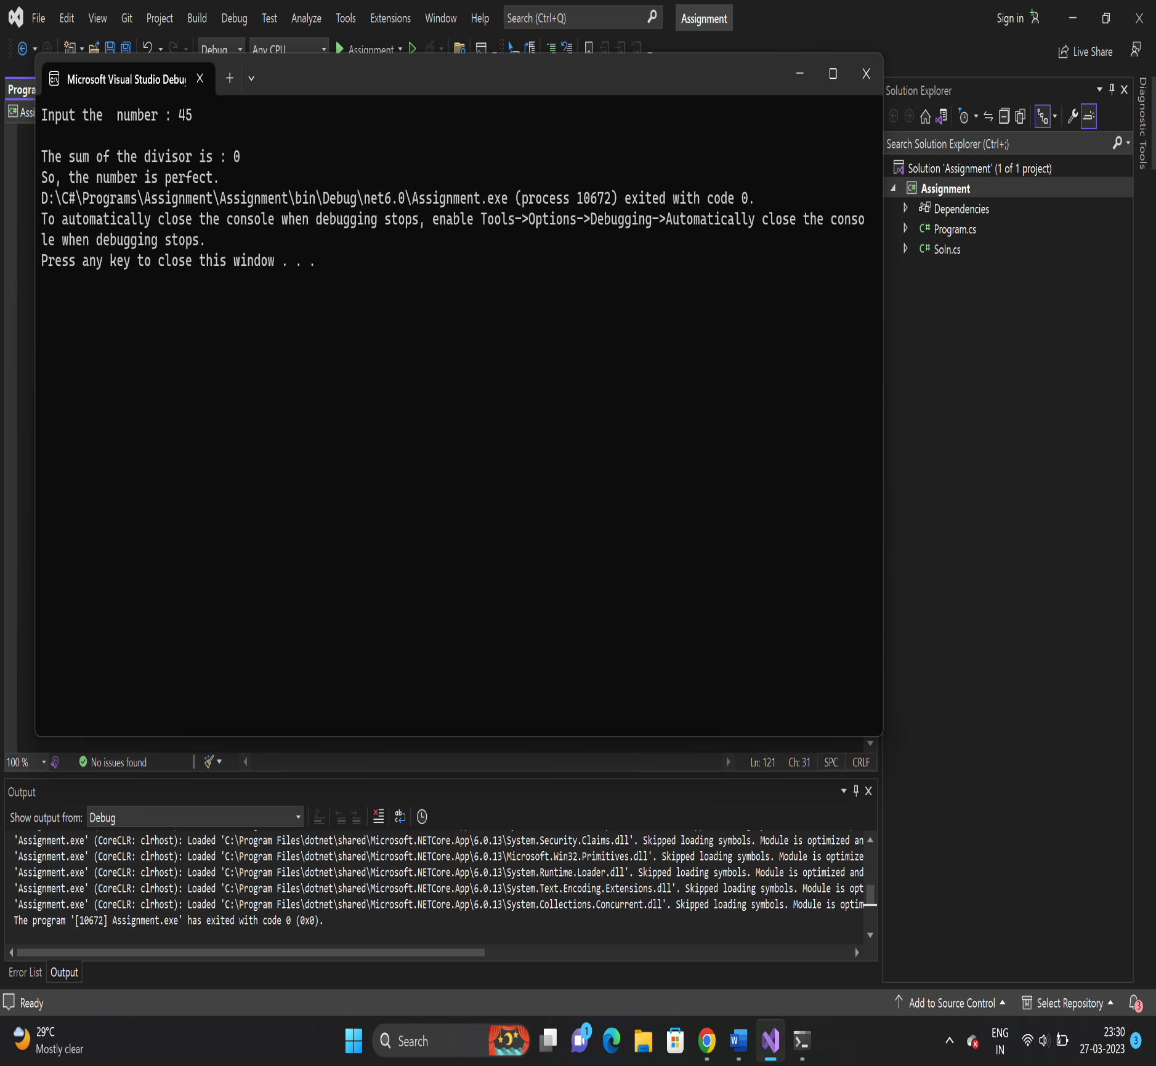

14. Write a program in C# Sharp to create a function to check if a given number is Prime number or

Not

class Soln

{

public void prime(int n)

{

int flag = 0;

for (int i = 2; i < n/2; i++)

{

if(n%i== 0)

{

flag++;

break;

}

}

if (flag == 0)

{

Console.WriteLine(n + " is a prime number");

}

else

{

Console.WriteLine(n + " is not a prime number");

}

}

}

//Driver Code

class Program

{

Soln soln= new Soln();

Console.Write("Input a number : ");

int n = Convert.ToInt32(Console.ReadLine());

soln.prime(n);

}

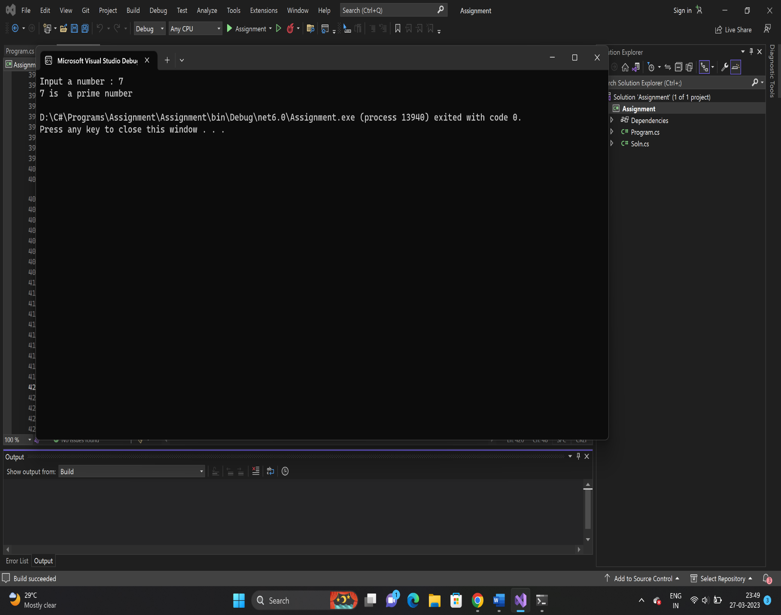

7. Write a C# Sharp program that calculates the sum of all prime numbers in an array of numbers

class Soln

{

public int primenumber(int count)

{

int[] arr = new int[10];

int[] parr = new int[10];

int SumofPrime = 0;

Console.WriteLine("Enter a Elements: ");

for (int i = 0; i < count; i++)

{

arr[i] = Convert.ToInt32(Console.ReadLine());

}

for (int i = 0; i < count; i++)

{

int flag = 1;

for (int j = 2; j <= arr[i] / 2; j++)

{

if (arr[i] % j == 0)

{

flag = 0;

break;

}

}

if (flag != 0)

{

SumofPrime += arr[i];

}

}

Console.WriteLine("Sum of prime numbers is " + SumofPrime);

return SumofPrime;

}

//Driver Code

class Program

{

Soln soln = new Soln();

int element;

Console.WriteLine("enter a array Length:");

element = Convert.ToInt32(Console.ReadLine());

PrimenumberSum primenumberSum = new PrimenumberSum();

soln.primenumber(element);

}

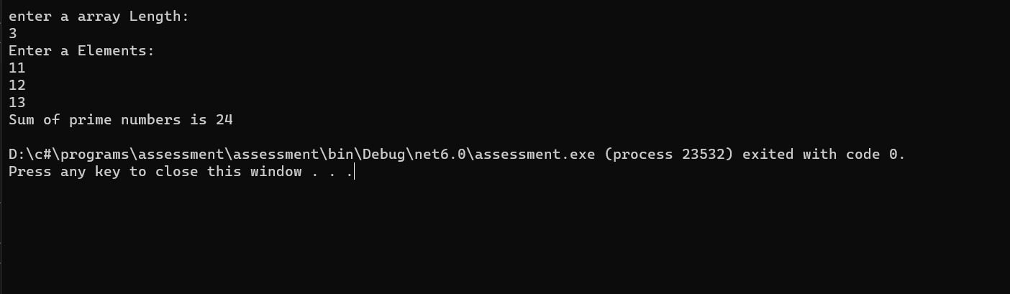

15. Write a program in C# Sharp to

a. create a function to check if a given string is Palindrome or not

b. create a function to check if a given number is Palindrome or not

class Soln

{

public void palindrome(string s, string revs)

{

for (int i = s.Length - 1; i >= 0; i--) //String Reverse

{

revs += s[i].ToString();

}

if (revs == s) // Checking whether string is palindrome or not

{

Console.WriteLine("String is Palindrome \n Entered String Was {0} and reverse string is {1}", s, revs);

}

else

{

Console.WriteLine("String is not Palindrome \n Entered String Was {0} and reverse string is {1}", s, revs);

}

}

}

//Driver Code

class Program

{

Soln soln= new Soln();

string s, revs = "";

Console.WriteLine(" Enter string");

s = Console.ReadLine();

soln.palindrome(s,revs);

}

}

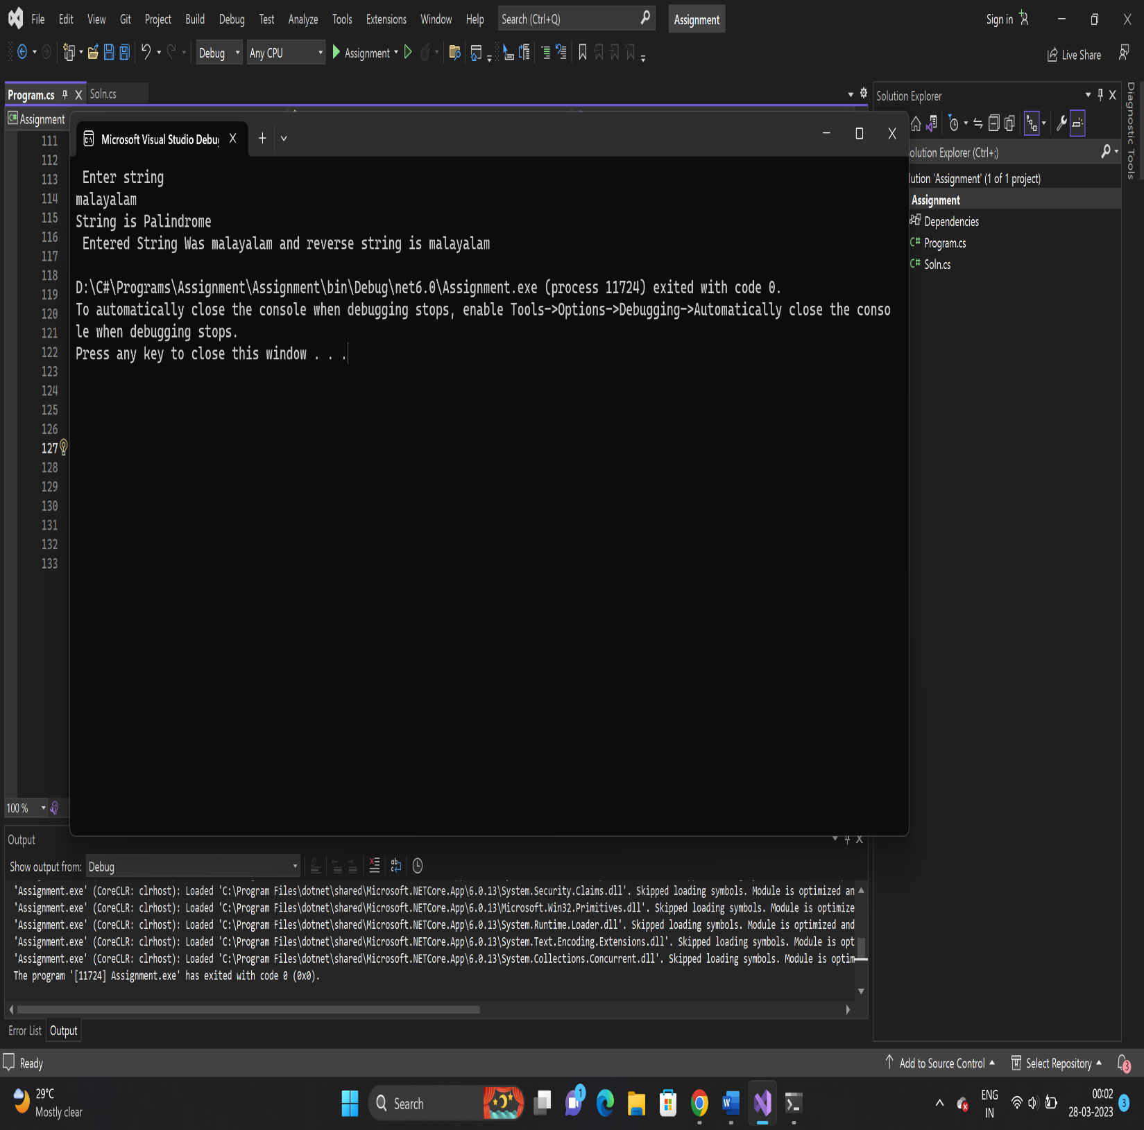

b) class Soln

{

public void palindrome(int num, int sum)

{

int t, r;

for (t = num; num != 0; num = num / 10)

{

r = num % 10;

sum = sum * 10 + r;

}

if (t == sum)

Console.Write("{0} is a palindrome number.\n", t);

else

Console.Write("{0} is not a palindrome number.\n", t);

}

}

//Driver Code

class Program

{

Soln soln= new Soln();

int num, sum = 0;

Console.Write("Input a number: ");

num = Convert.ToInt32(Console.ReadLine());

soln.palindrome(num,sum);

}

}

